Project 4
Data Discovery
It appears that this dataset is a noisy version of the MNIST digit set with the noise coming from some inner sense of fashion. A plot of some of the images is shown below.
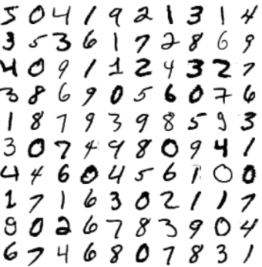  Figure 1: Clean project dataset. | 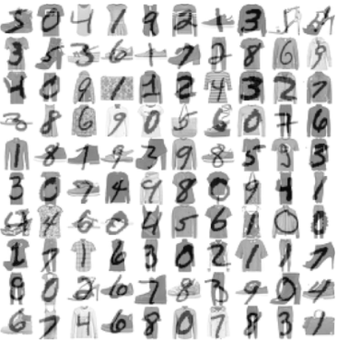  Figure 2: Noisy project dataset.

Choosing an Architecture
I explored a few different architectures of autoencoders to find the one that works the best with this particular dataset. It was proven to be difficult to find various results that work. Here, I outline which architectures I tried and how the outputs looked.
Stacked Autoencoder
Starting out from an architecture mentioned in the book, I initialized my first attempt using the a stacked approach with a few dense layers. The code that I use to attempt this can be found in Appendix A. The results of this came out to be very odd and showed that the encodings all turned out the same and completely unrecognizable. I am not sure why the autoencoding worked in this way, however it was rather bizarre and I showcase some of my comparisons below. First is a side-by-side comparison of a few images and second is a grid showing an assortment of images.
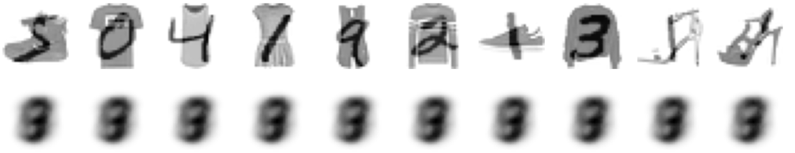
Figure 3: First autoencoder output, side-by-side.
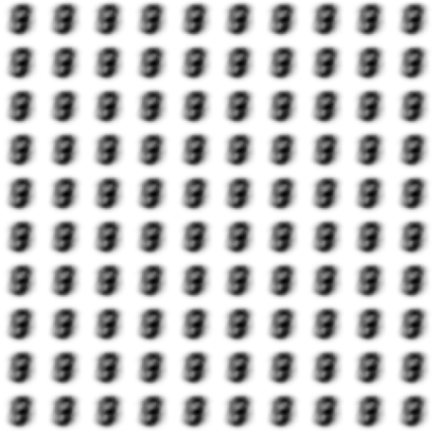
Figure 4: The grid of the ‘different’ image encodings.
As can be seen by the above, something strange is going on and nothing that I did was able to remedy this. So I moved on to something a little more intuitive.
Convolutional Stacked Autoencoder
Upon finding the lack of success with the normal autoencoder, I opted for the convolutional approach in hopes that since these are images, the results would be much more recognizable. My initial attempts with the code outlined in Appendix B garnered results that were much more promising and are shown below without any parameter reduction.
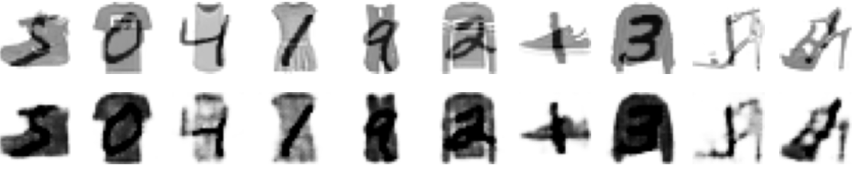
Figure 5: Side-by-side with convolutional autoencoder.
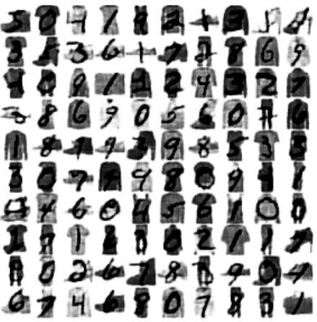
Figure 6: Grid view with the convolutional autoencoder.
My next step was attempting to bring down the number of parameters and making it work better on the eyes. I found that initially setting the training epochs higher made a much better outline, but I still needed to reduce the parameter count. The following table shows the steps that I took and snapshots of a few recoveries that correspond to the changes.
Table 1: Table of steps taken to reduce model parameters.
Model Modification | Total Parameters | Training Time (sec) | Image Comparison
Original (5 epochs) | 46,529 | 183 | 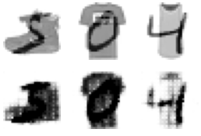
Remove one layer from each (enc, dec) and filter sizes (5 epochs) | 2,433 | 76 | 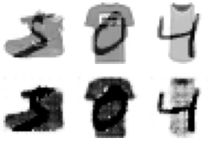
Increase training time to 20 epochs | No change | 7,781 | 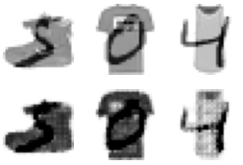
Decrease training time to 10 epochs | No change | 3,615 | 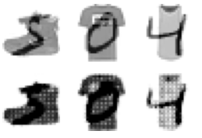
I ultimately decided to go with the 20-epoch training time. Although it can sometimes decrease the visibility of already noticeable numbers, when it comes to the more difficult cases like the 1st image, it does a better job of clearing out the number and making it much more visible.
Aside from searching with my own eye, there was no implementation for validation accuracies and whatnot. I had no hard time classifying all the images as they were given and the autoencoder only made them easier to distinguish with my eyes alone. I even double-checked with my roommate, who also had no problem classifying the input and the output.
Results
The resulting architecture was formed to look like the output below. The first summary corresponds to the encoder, the second to the decoder, and the third to the total autoencoder.
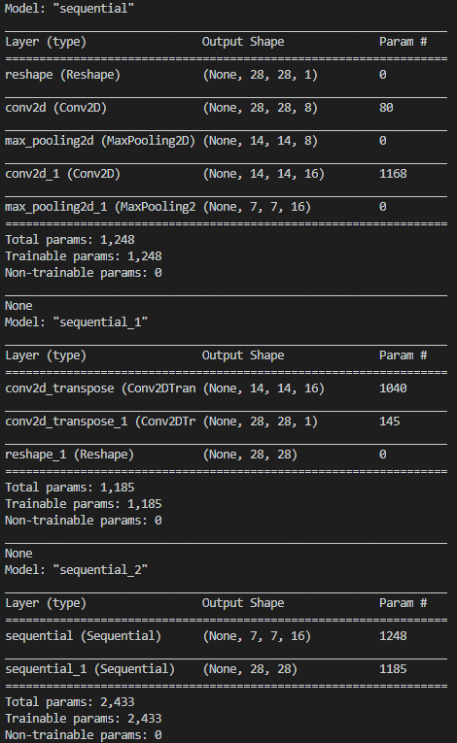
Figure 7: Total summary of the model.
Appendix A: Defining the Normal Autoencoder
stacked_encoder = keras.models.Sequential([
keras.layers.Flatten(input_shape=[28, 28]),
keras.layers.Dense(100, activation="selu"),
keras.layers.Dense(30, activation="selu"),
])
stacked_decoder = keras.models.Sequential([
keras.layers.Dense(100, activation="selu", input_shape=[30]),
keras.layers.Dense(28 * 28, activation="sigmoid"),
keras.layers.Reshape([28, 28])
])
stacked_ae = keras.models.Sequential([stacked_encoder, stacked_decoder])
stacked_ae.compile(loss="binary_crossentropy",
optimizer=keras.optimizers.SGD(lr=1.5))

Appendix B: Defining the Convolutional Autoencoder
conv_encoder = keras.models.Sequential([
keras.layers.Reshape([28, 28, 1], input_shape=[28, 28]),
keras.layers.Conv2D(16, kernel_size=3, padding="same", activation="selu"),
keras.layers.MaxPool2D(pool_size=2),
keras.layers.Conv2D(32, kernel_size=3, padding="same", activation="selu"),
keras.layers.MaxPool2D(pool_size=2),
keras.layers.Conv2D(64, kernel_size=3, padding="same", activation="selu"),
keras.layers.MaxPool2D(pool_size=2)
])
conv_decoder = keras.models.Sequential([
keras.layers.Conv2DTranspose(32, kernel_size=3, strides=2,
padding="valid",
activation="selu",
input_shape=[3, 3, 64]),
keras.layers.Conv2DTranspose(16, kernel_size=3, strides=2, padding="same",
activation="selu"),
keras.layers.Conv2DTranspose(1, kernel_size=3, strides=2, padding="same",
activation="sigmoid"),
keras.layers.Reshape([28, 28])
])
conv_ae = keras.models.Sequential([conv_encoder, conv_decoder])
conv_ae.compile(loss="binary_crossentropy",
optimizer=keras.optimizers.SGD(lr=1.5))

